Introducing our ECIR consulting solution

The objective of our presentation is to enable you appreciate our complementary solution to the sap netweaver.
The presentation is structured as follows:
- Overview of the solution,
- Stakeholders,
- Expected gains,
- Embedding our solution in those developed by SAP partner solutions
- Technical overview of the solution
- Comments on the solution’s technical approach
- Fees

Table of content
1. Overview of the solution 3
1.1. The client part 3
1.2. The server part 4
1.3. Reporting 4
1.1.1. Reporting can be done by SAP LUMIRA 4
1.1.2. Excel can be used to build tables or graphs. 5
1.4. The solution 5
1.1.3. Fields of application 5
1.1.4. Improvements on performance 5
2. Stakeholders 6
3. Expected Gains 7
3.1. For the Management 7
3.2. For users 7
3.3. For the IT framework 7
3.4. For developers 7
4. Embedding our solution in those developed by other SAP partners 8
5. Technical Overview of the solution 9
5.1. The client part 9
5.2. The server part 9
6. Comments on the solution’s technical approach 10
7. Licenses 11
7.1. The client part 11
7.2. The server part 11
7.3. Maintenance contract 11

Overview of the solution
Our solution is based on two main components:
- The client part
- The server part
These features are further described below.

The client part
The client part consists only of technical SAP objects, data dictionary objects and programs/classes in ABAP. These characteristics guarantee the durability of the tool for the many years.
This technology is flexible, freely editable or can be used as reference for specific developments as desired by users.
The client part aims at:
- Referencing all changes on the control policy
- Managing the validity of these policies
- Ensuring quality control of these policies
Screenshot of a control program
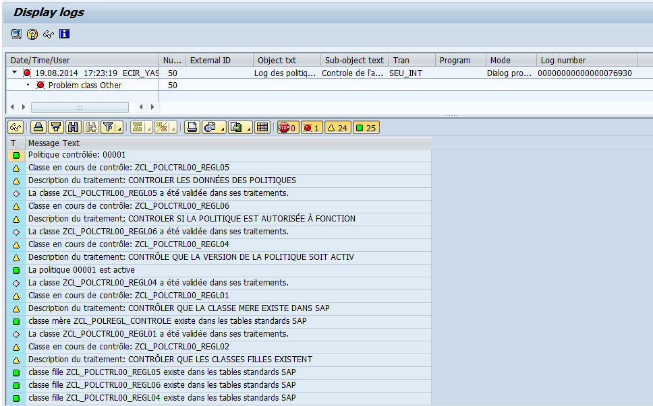
All technical objects produced or under production can be controlled under SAP.
Completed tests can be modified and adapted as and when needed. All language installed can be used.

The server part
The server uses a technology that is independent from SAP.
Its purpose is to monitor codes undertaken within the SAP system landscape. To achieve this role, it is advisable to allow it connect to the client part installed on the servers. This is recommended but not compulsory. An acceptable workaround is to transfer flat files.
Whether you have 2-3 SAP servers or a hundred, you can supervise them from your server in order to monitor reliability.
Control possibilities:
- Confirm that the processing policies on the machine prod are the exact replica of what was defined,
- Check the validity of rules,
- Check logs processing.

Reporting

Reporting can be done by SAP LUMIRA

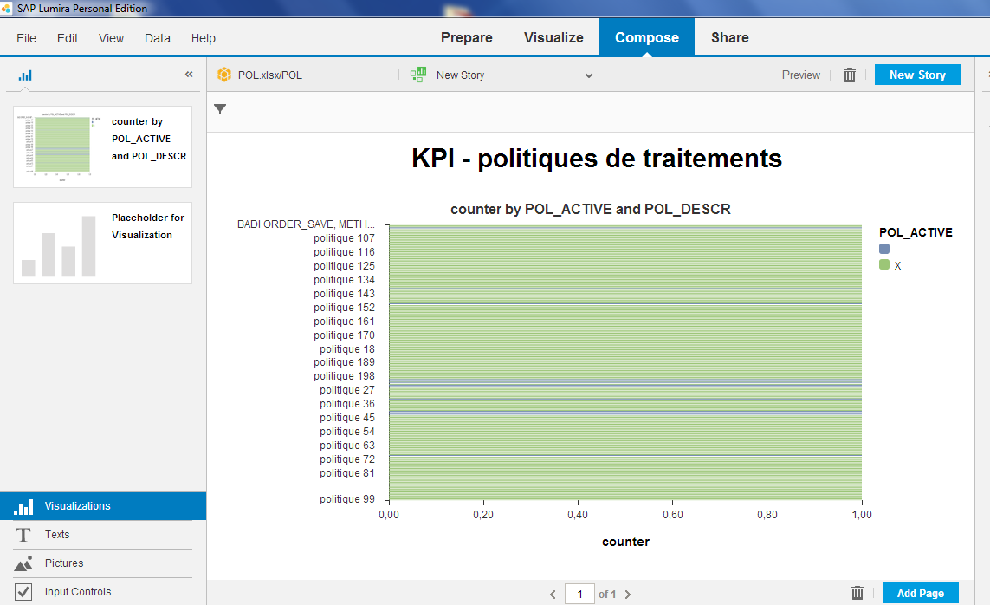

Excel can be used to build tables or graphs.
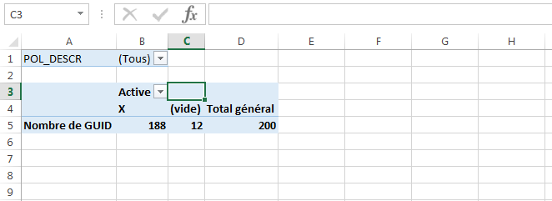

The solution

Fields of application

SAP standard extensions (USER EXIT, CLIENT FUNCTION, BADI)
Incoming interfaces (data control)
Outgoing interfaces (Data preparation)
Printing
Price maintenance
Managing Service rates
Managing access rights

Improvements on performance

Limiting tests in upgrades
Limiting non regression tests
Increased visibility of processing
Reduction in the use of the server memory
Rapid increase in SAP programs.

Stakeholders

The advantage of our solution is to bring together all stakeholders involved in the maintenance and evolution of the SAP system:
- The management
- The technical board
- Users
- Developers

Using our solution allows management and users to be the indirect beneficiaries of this technical solution.
The technical board, as well as developers are the direct beneficiaries of the solution which facilitates and simplifies their work.

Expected Gains

For the Management
Performance indicators on change are achieved.
Reduced budgets for testing phases and more secured budgets.
The ability to replace the previous solution within seconds after decision: almost 0 risks and no additional cost.

For users
Enough room to set up more frequent changes.
Less time spent in testing phases.
Users do their job.

For the IT framework
More precise definition of changes
Greater facility to trace changes, justifying them using indicators
Greater facility to define the necessary budgets to support changes
Greater facility for work control: going through every achievement with no impact on users (risk 0).
Extended working skills, even without expertise.
Developments parallelization.

For developers
The following benefits have been observed in the businesses using SAP solutions:
- Greater productivity with applications
- Shorter time to operationalize applications
- Easier to maintenance
- Easier testing of new applications, self-monitoring
- Facility to undo changes without losing codes.

Embedding our solution in those developed by other SAP partners

The main objective of this solution is to facilitate work on technical projects.
The SAP partner solution is therefore an opportunity to improve productivity for the SAP solution user.
Enabling SAP partners to use this solution will ensure subsequent cost reduction for users and even more save costs for SAP partners in the management of their solution and its maintenance...
Any SAP partner is able to use this solution, deploy it within their clients, while ensuring traceability of changes and significantly improves communication with their clients.
There is greater serenity in the client relationship.
For clients, having access to such a solution within their SAP system landscape with SAP partners using it facilitates communication, but also makes it easier to trace any other available solution, in a smooth and unique way.

All SAP partners should contact us. Our solution is not rights free; it is listed in a namespace protected by SAP.

Technical Overview of the solution

Our solution is based on two components:
- A client part deposited on each SAP NETWEAVER server
- A server part, external to the SAP solution.

The client part

ABAP format, usable from any version of SAP NETWEAVER
Scalable
Accessible through web services and or BAPI
Will integrated into a Web Dynpro component FOR ABAP, Floor Plan Manager and WEB UI technology.

The server part

The server part is external to the SAP because of an HMI optimized to better fit the desired treatment.

A future change will be to build up a SAP NETWEAVER platform in a bit to integrate even more features.

Comments on the solution’s technical approach
The solution package was introduced 5 years ago in the books produced by the TYALGR publishing house:
- The ABAP procedure book on the subject, published in 2010, presents a general view of the processing logic of our solution
http://www.ecom-ecir.fr/abapobjet-xml-353-821.html

- The book “From Dynpro to Web Dynpro for ABAP” shows an application of this method of work and thus the foundation of our tool
http://www.ecom-ecir.fr/liv2012004-du-dynpro-au-web-dynpro-for-abap-xml-353-843.html

This solution allows skilled ABAP Developers to work with confidence on their various solutions.
There is no need to be an ABAP expert to be able to use or develop this solution for business.
A key advantage of our solution is to build the skills of internal teams in a simple and stress-free manner. It also simplifies the management and coordination work of management teams.

Licenses

The client part

The solution is sold at 1000 Euros per SAP NETWEAVER instance, for SAP landscape only, nothing for tests serveur.
This solution is in ABAP format.

The server part
The SERVER solution is based on different technologies: WINDEV, #net, JAVA...
The server part is sold to manage all servers that install the client part.

Maintenance contract

The client part in ABAP requires very little maintenance, not to say any.
Maintenance is offered at a single price of 15% of the number of installations of the client part.
A specific intervention can be provided for 950 Euros per day, fees not included.

Client solution is at the single price of 1000 Euros per SAP NETWEAVER installed.
Various control and administration programs in ABAP are provided.

The server part can be defined according to different technical solutions based on technical expertise available.

Contact us at: Commercial@ecir.fr
www.ecir.fr

